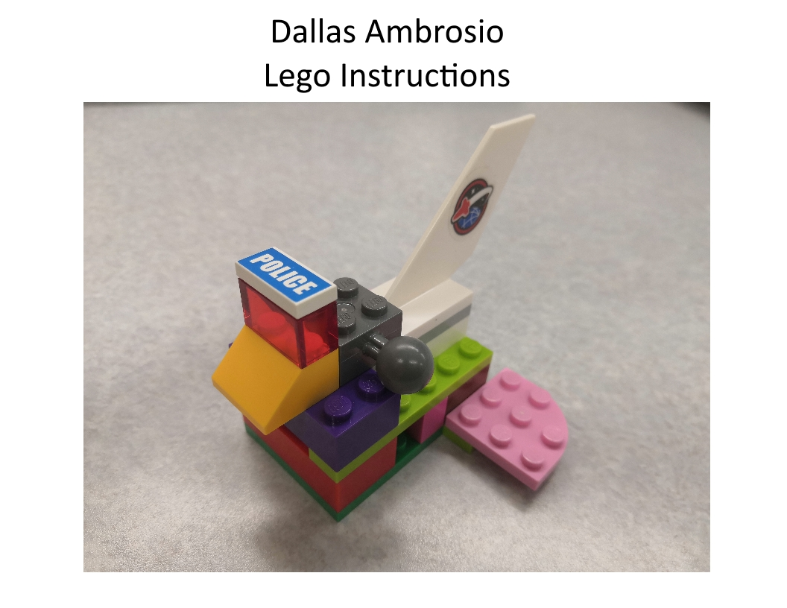

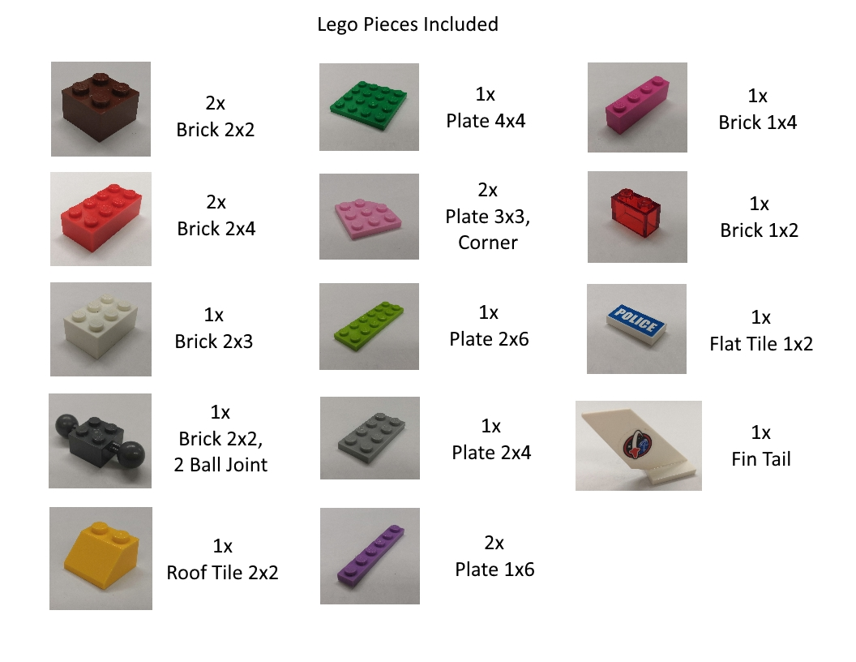

1. 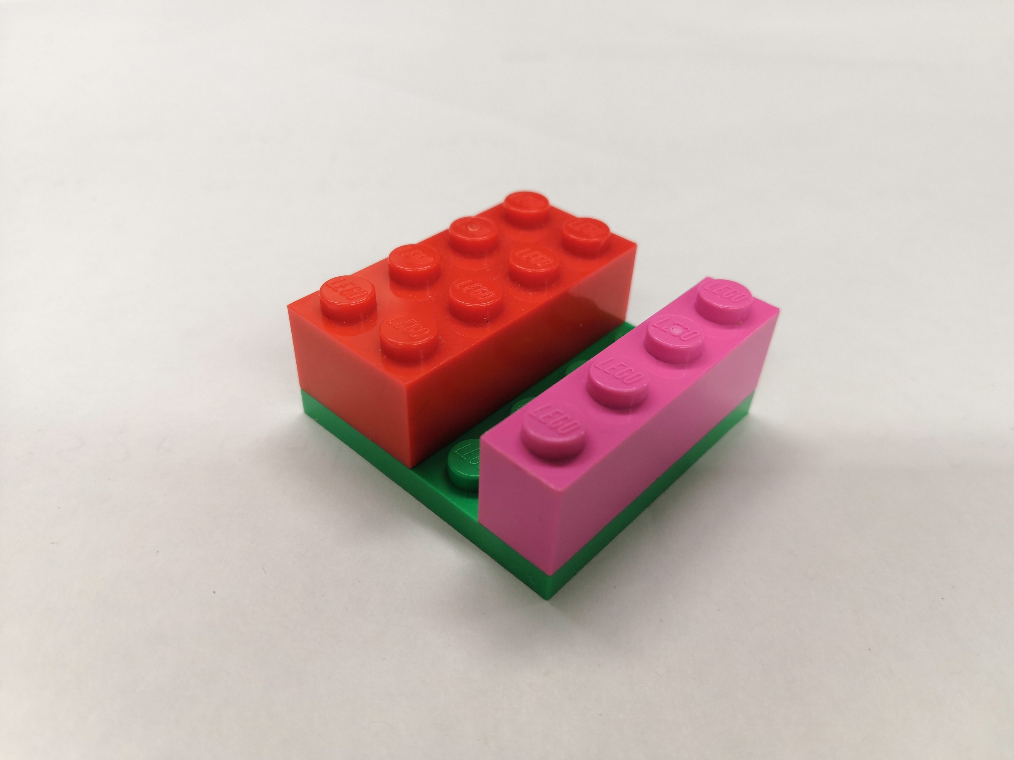Attach a ***Brick 2x4*** to half of the top side of the Plate 4x4. Attach the ***Brick 1x4*** to the ***Plate 4x4*** opposite the ***Brick 2x4***, leaving an open row between them.

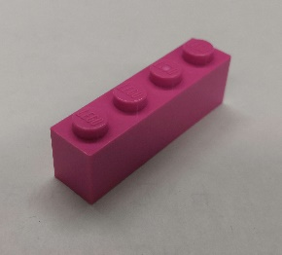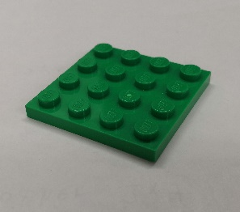

1x 1x

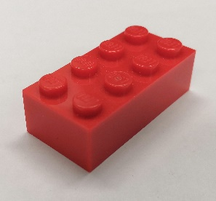

1x

1. 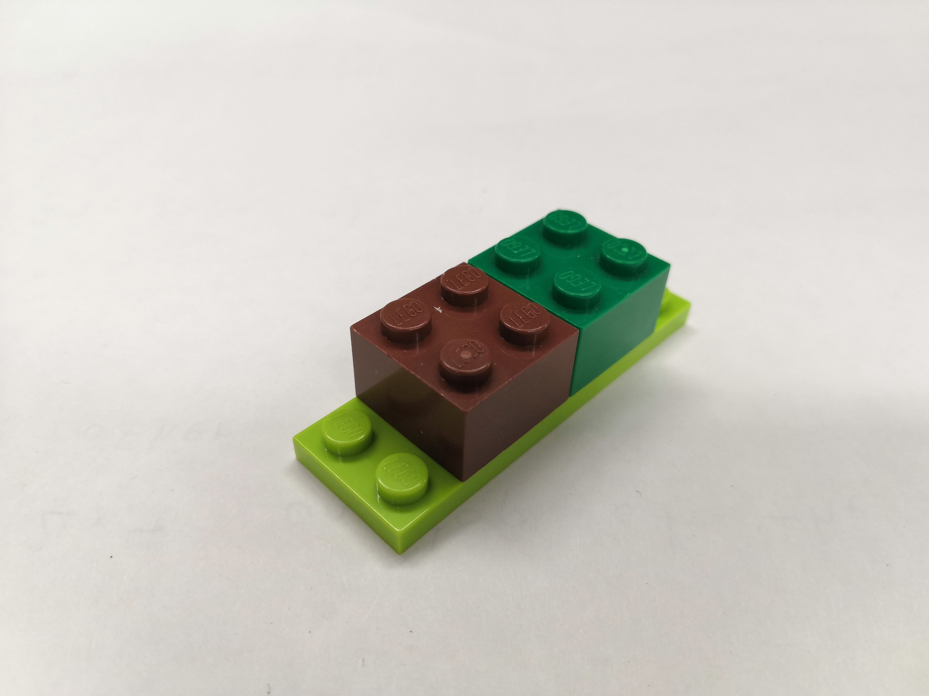Set the structure off to the side for now. Attach the two ***Brick 2x2***s to the center of the ***Plate 2x6***, leaving an open row on either side.

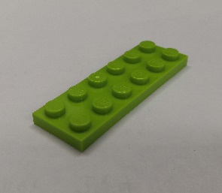

1x

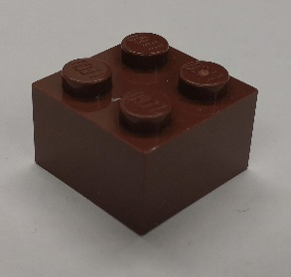

2x

1. 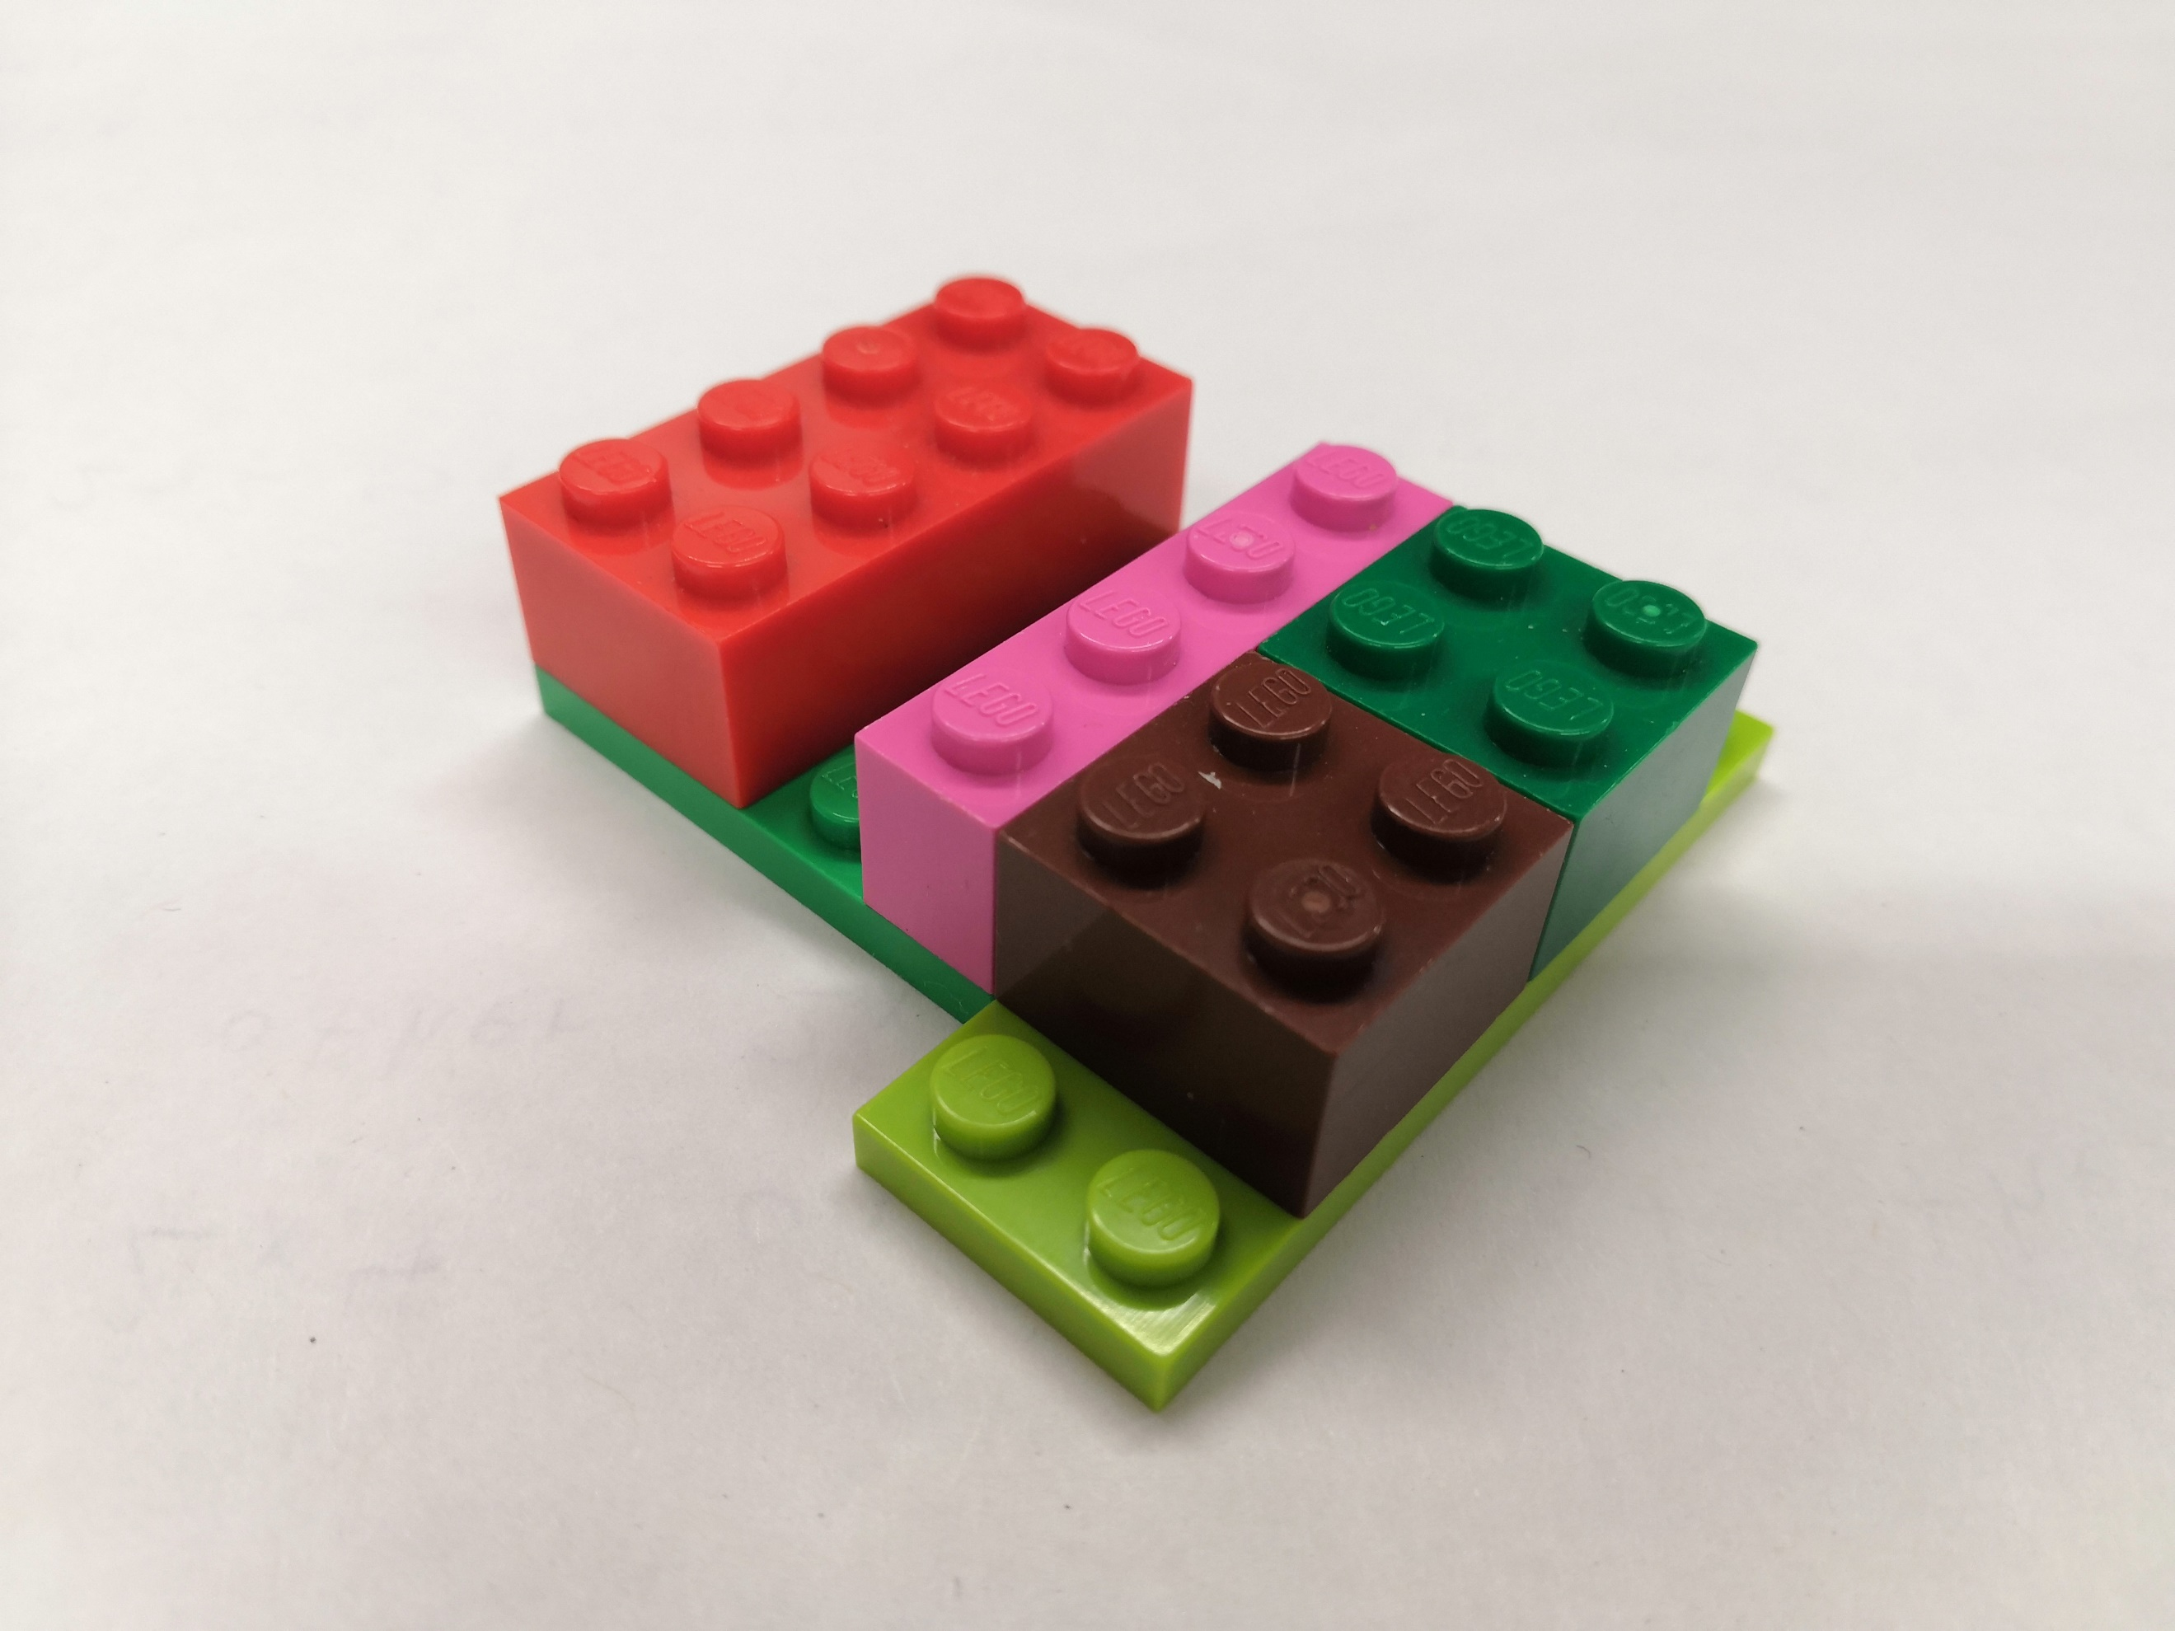Set the two structures made next to each other so that the two ***Brick 2x2***s are centered and touching the ***Brick 1x4***.
2. Attach the two ***Plate 1x6***s to the top of either side of both structures, connecting them. Leave no overhang except for over the gap between the ***Brick 2x4*** and ***Brick 1x4***.

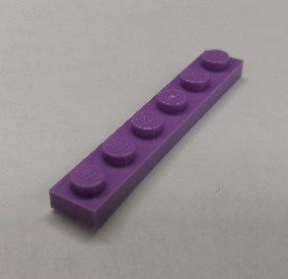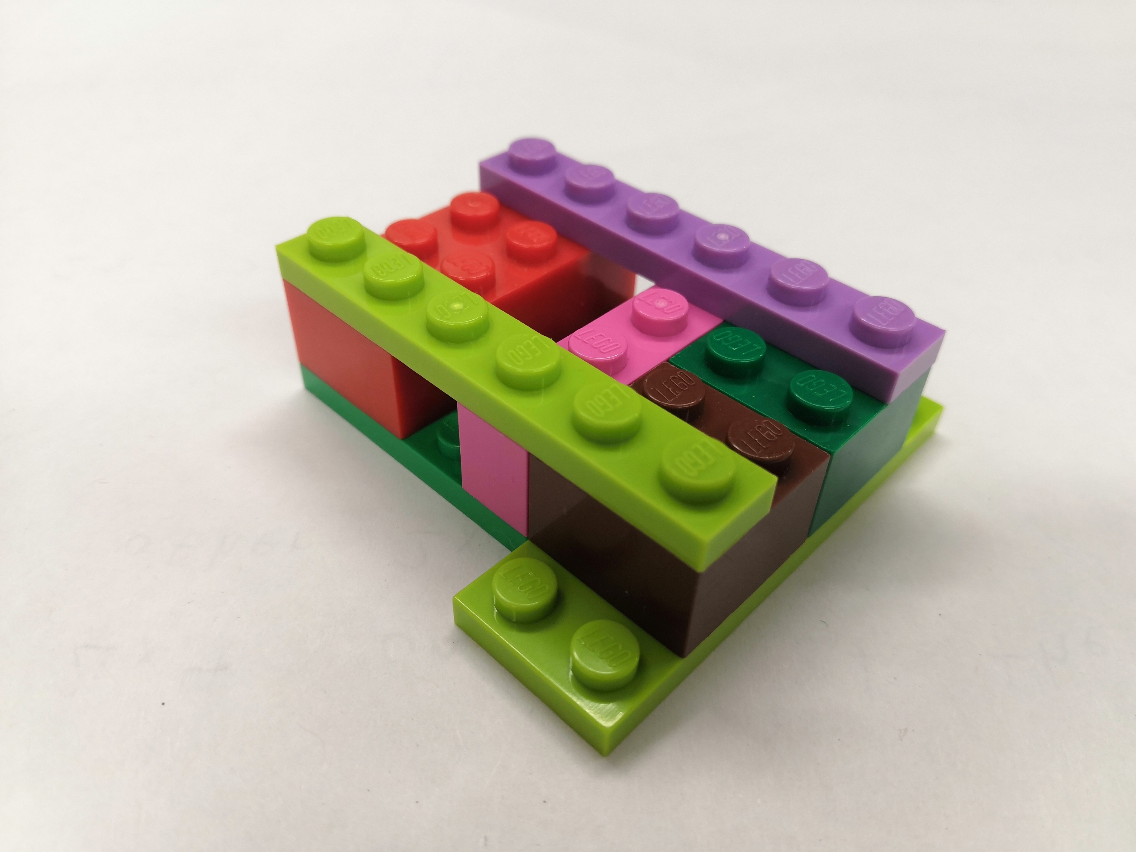

2x

1. Attach the two ***Plate 3x3 Corner***s to the open rows on either side of the two ***Brick 2x2***s so that the rounded corners are facing out, away from the structure.

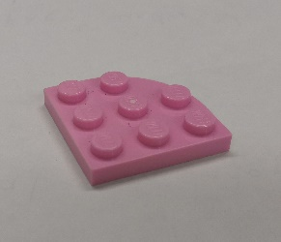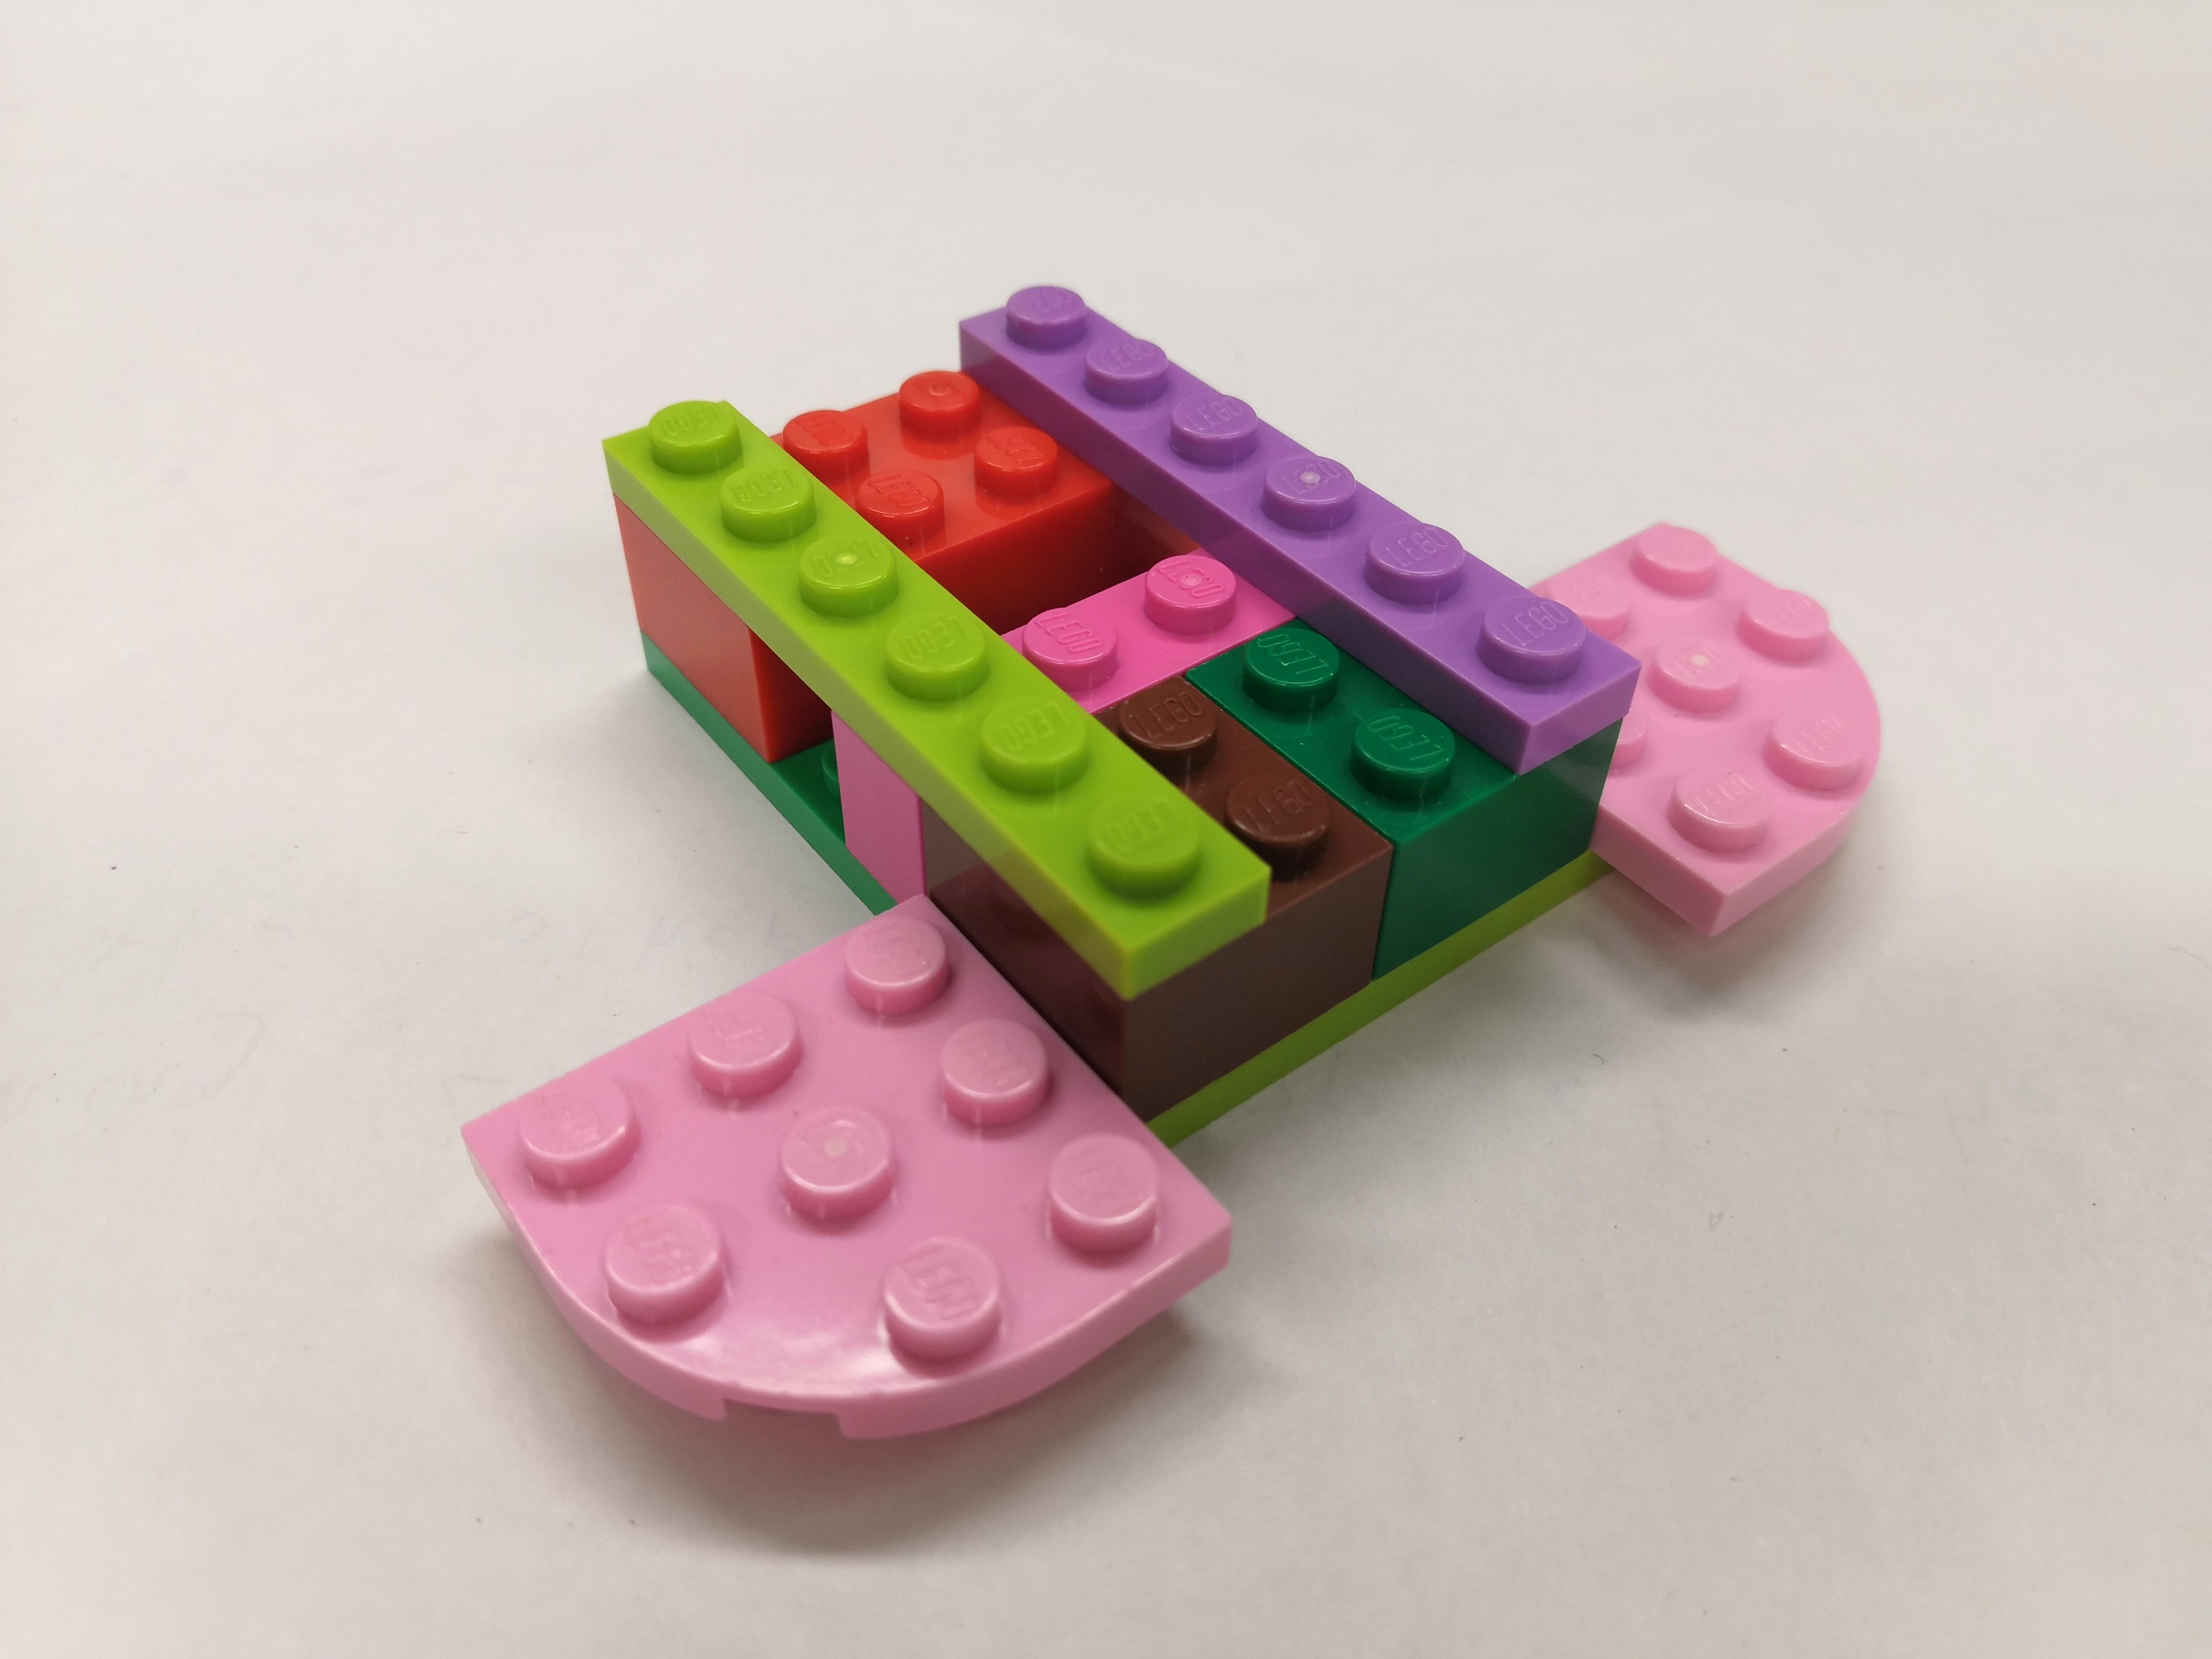

2x

1. Place the remaining ***Brick 2x4*** over the other ***Brick 2x4***, bridging the ***Plate 1x6***s. In the open space above the two ***Brick 2x2***s and the ***Brick 1x4***, attach the ***Brick 2x3***.

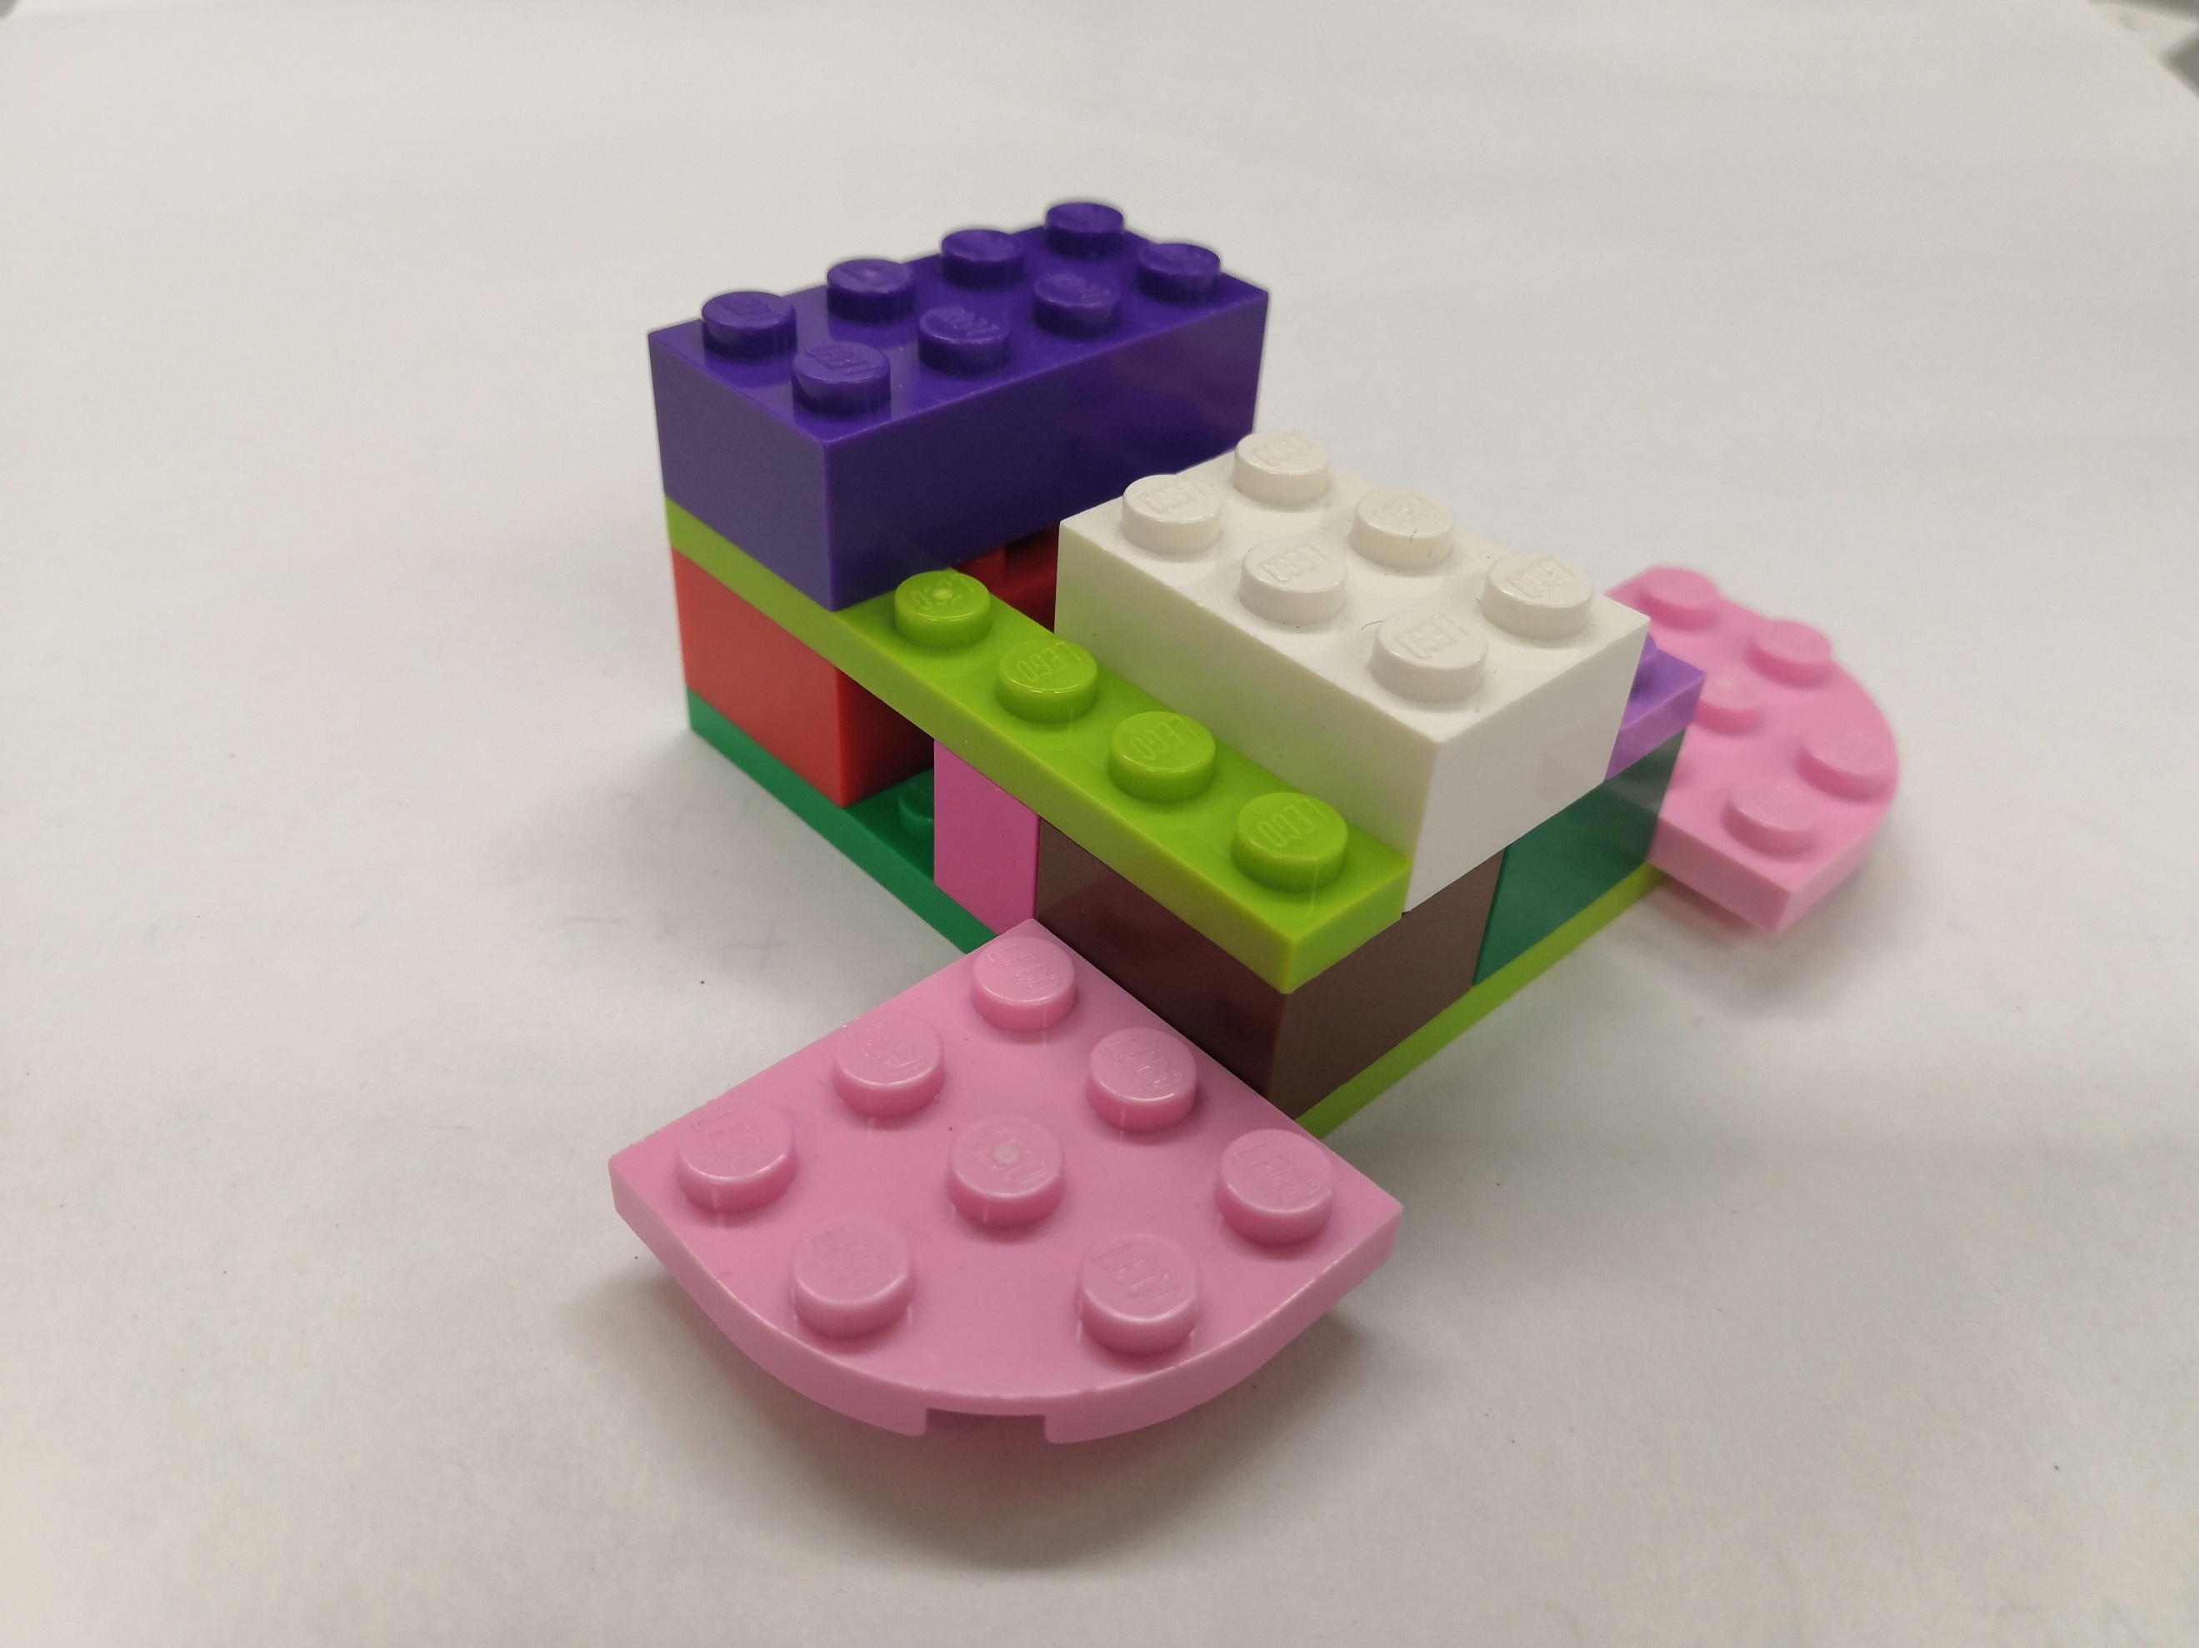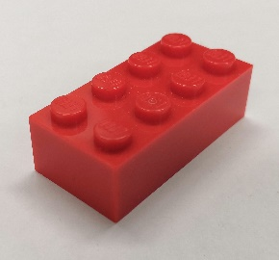

1x

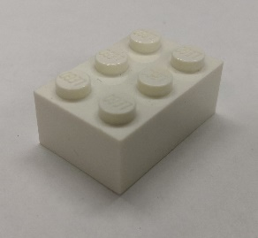

1x

1. Attach the ***Plate 2x4*** to the top of the ***Brick 2x3*** so that the overhang touches the ***Brick 2x4***.

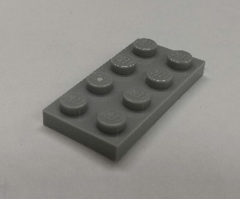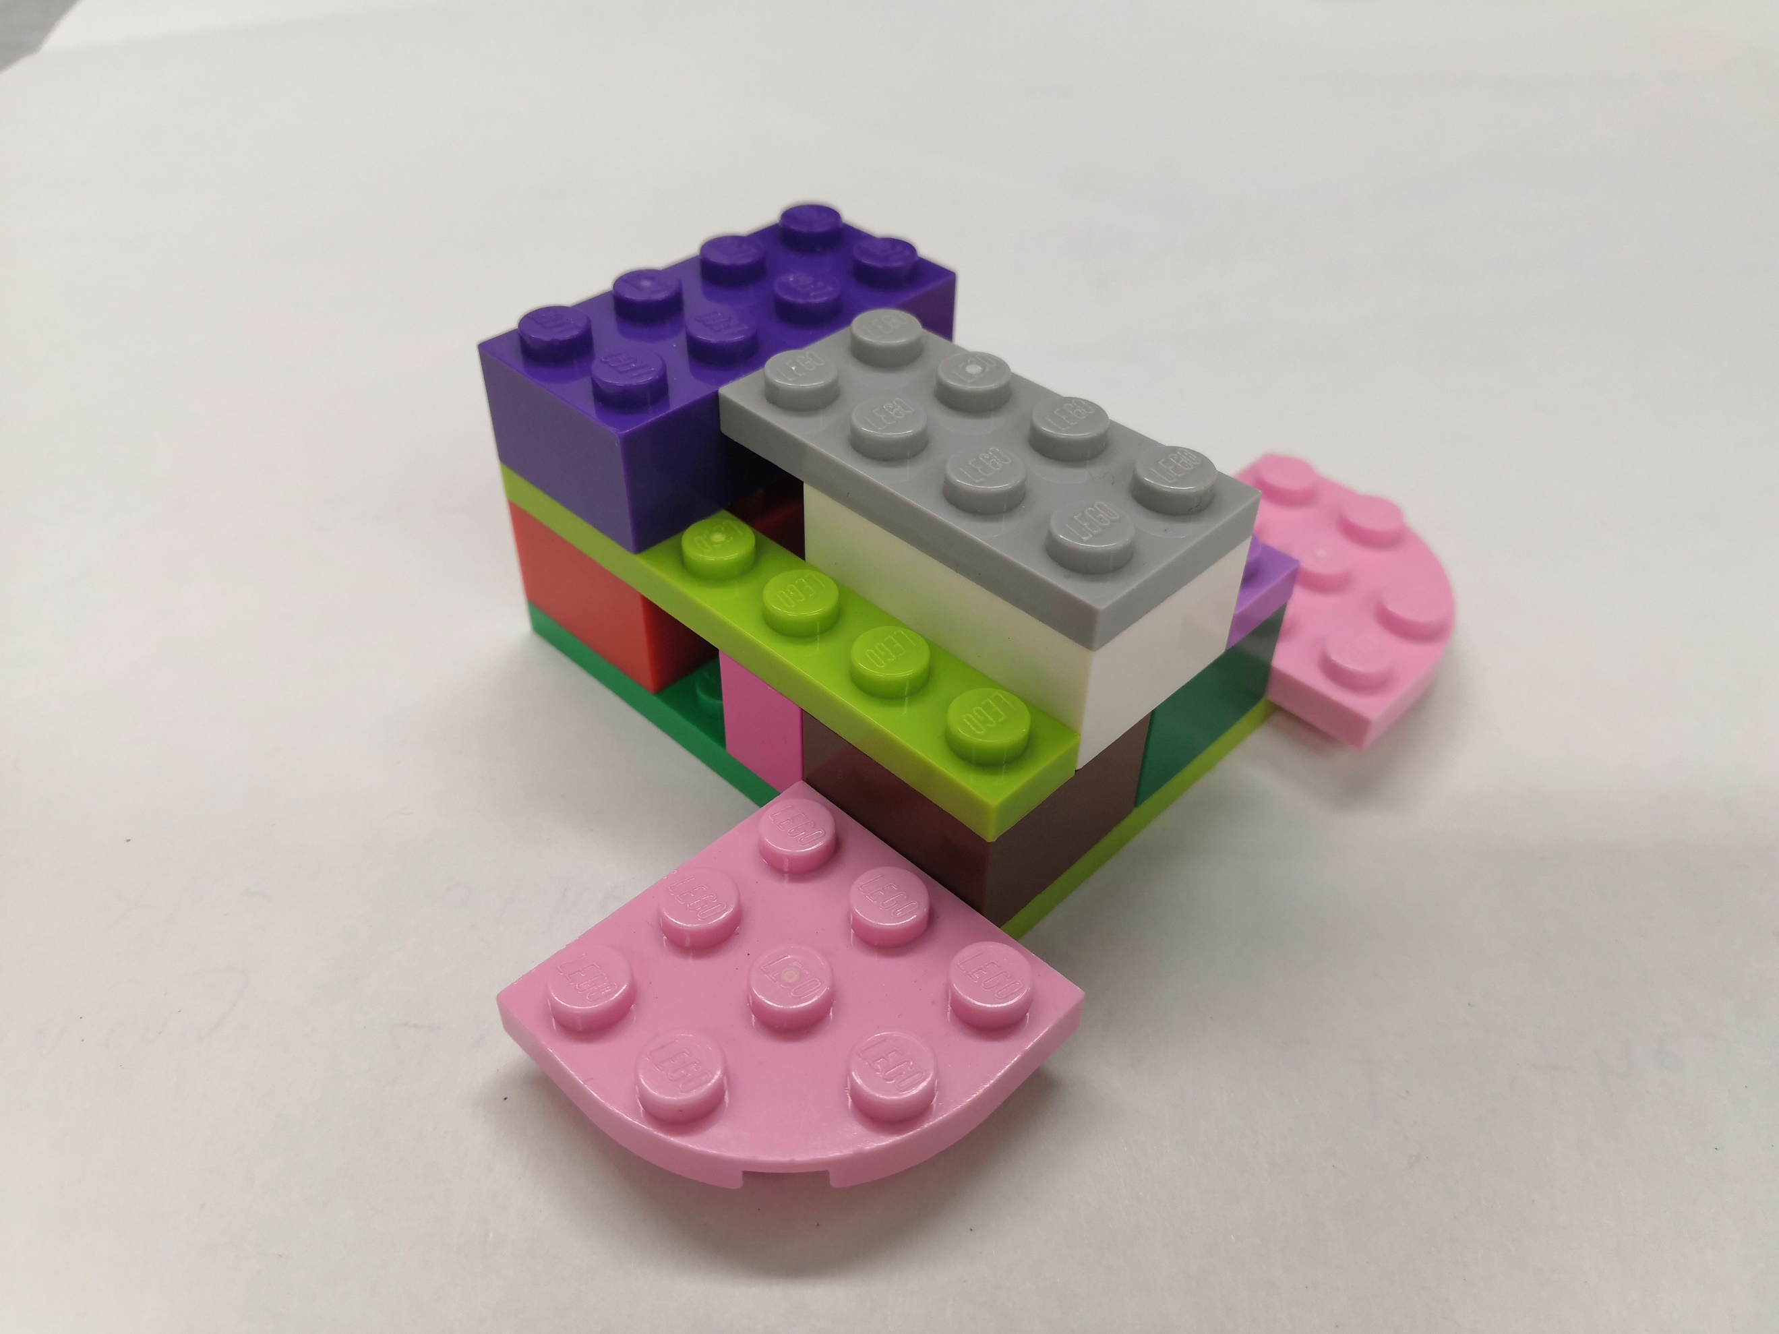

1x

1. 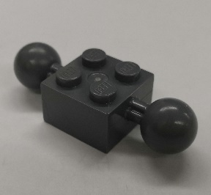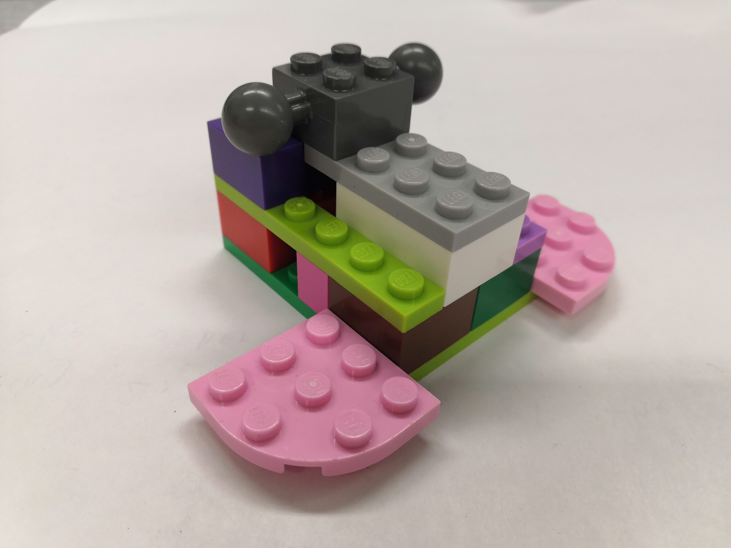Connect the ***Brick 2x4*** and ***Plate 2x4*** with the ***Brick 2x2, 2 Ball Joint***. The joints will face the same sides that the ***Plate 3x3 Corner***s are placed.

1x

1. 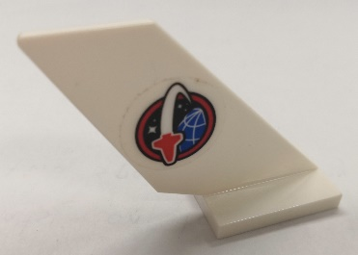Place the ***Fin Tail*** on the remaining open space of the ***Plate 2x4***, leaning away from the structure.

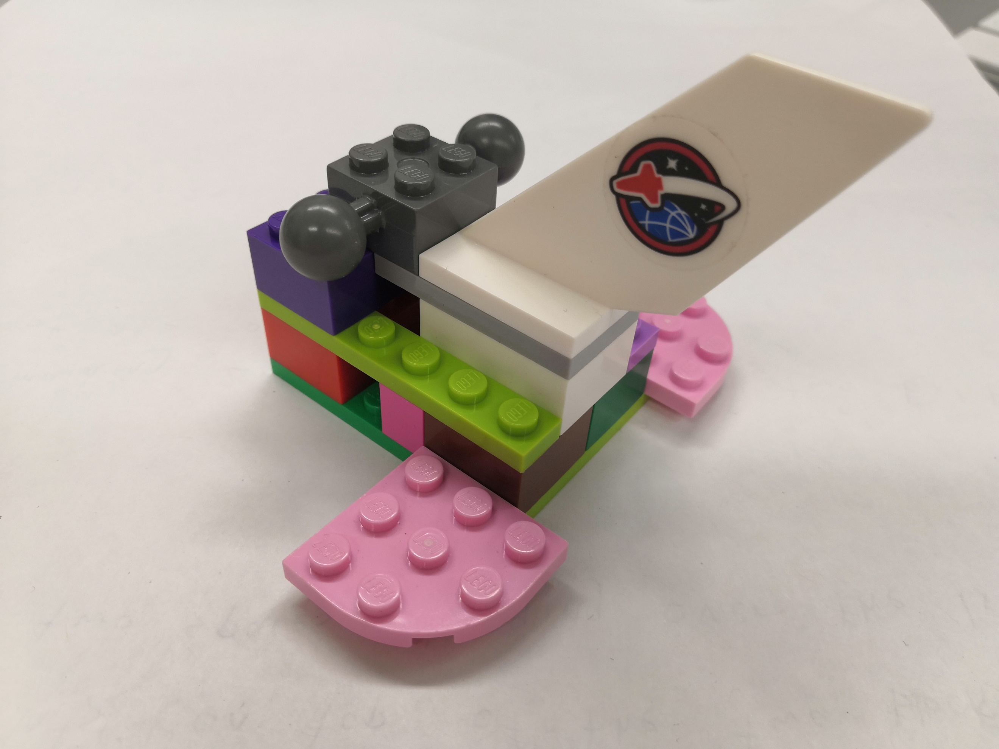

1x

1. 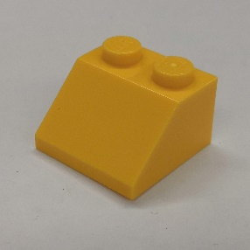Attach the ***Roof Tile 2x2*** centered top of the ***Brick 2x4*** so that it hangs over the edge, slant facing away from the structure and the opposite side touching the ***Brick 2x2, 2 Ball Joint***.

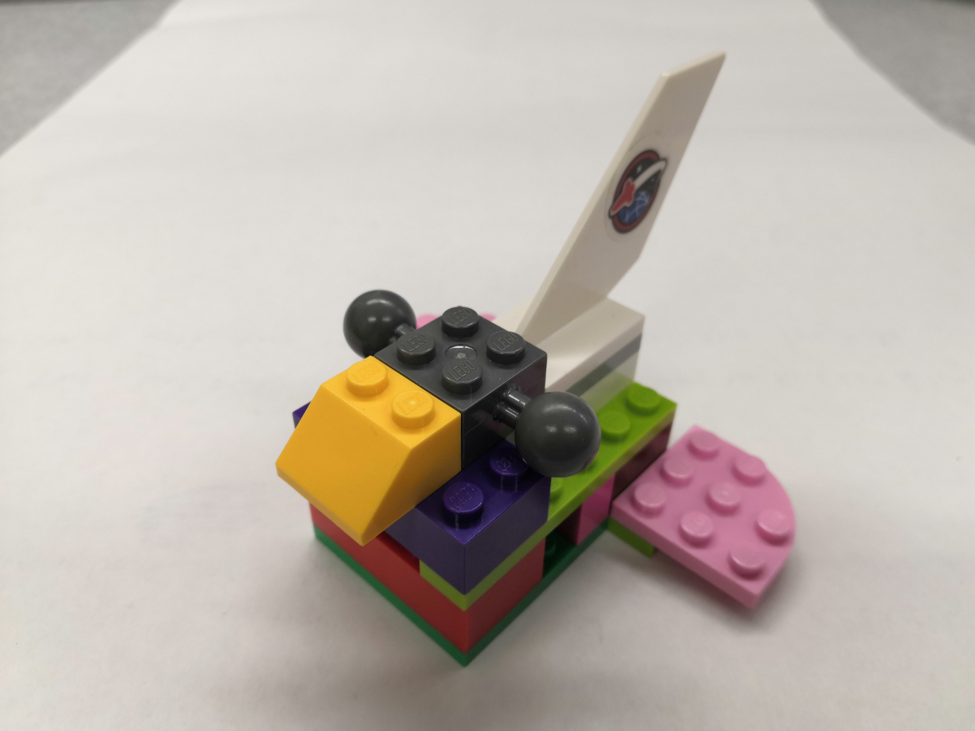

1x

1. Attach the ***Brick 1x2*** to the open spot on top of the ***Roof Tile 2x2***.

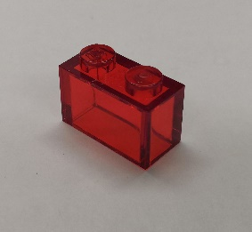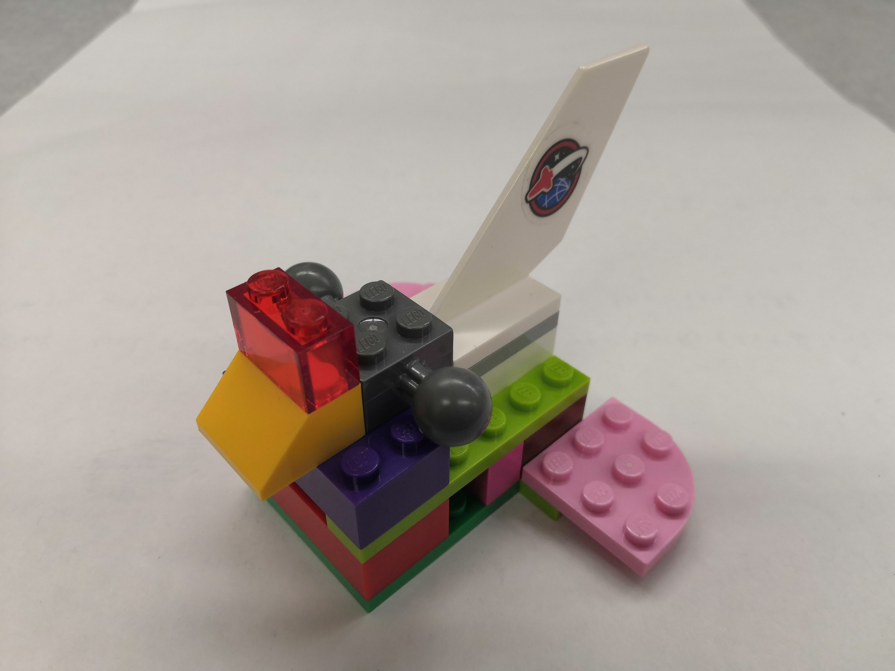

1x

1. 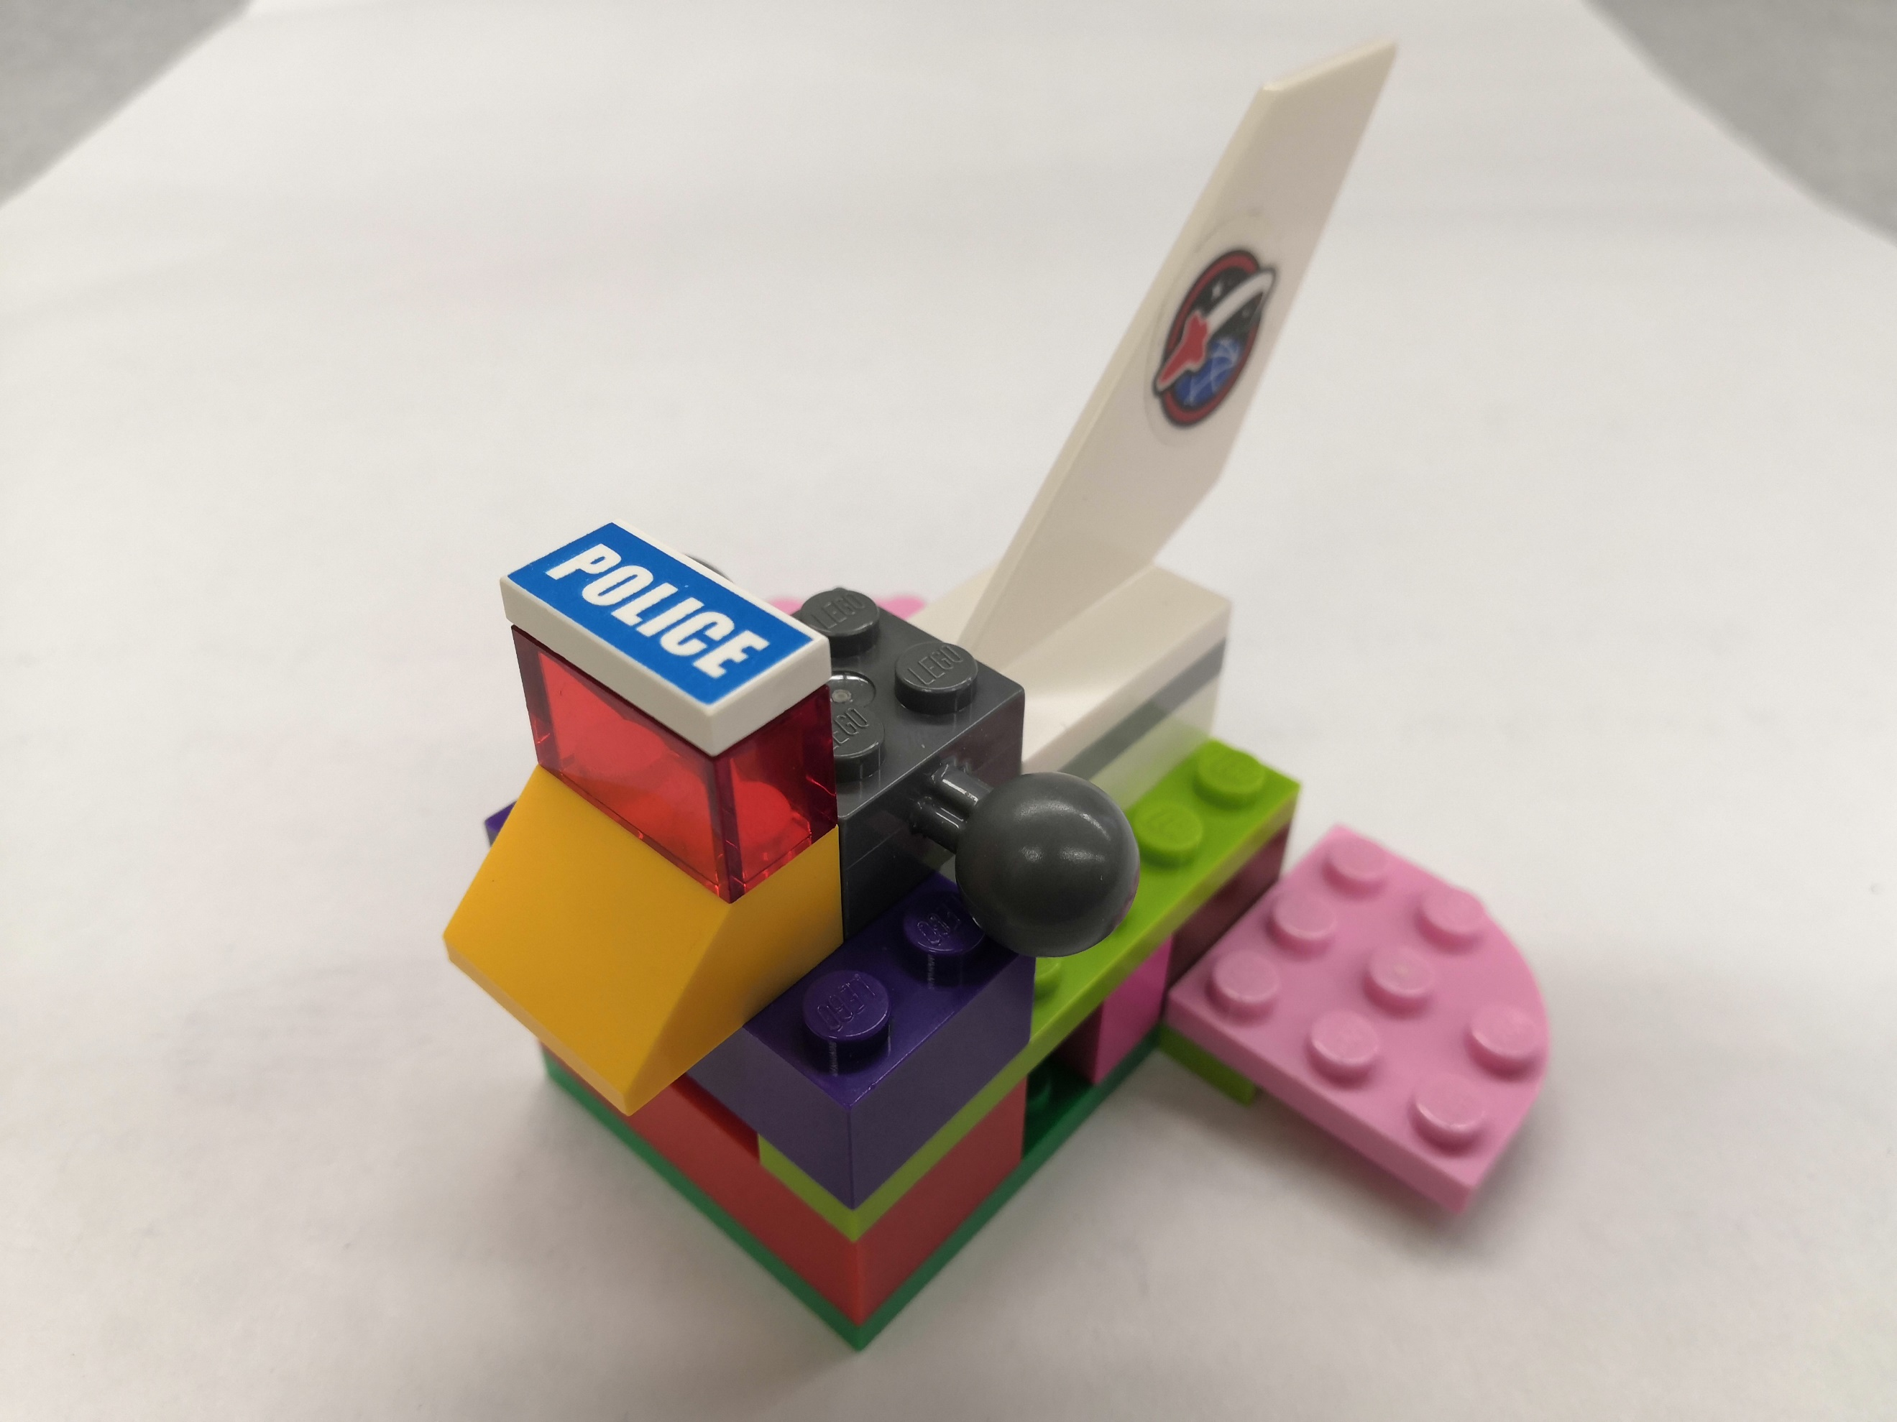Attach the ***Flat Tile 1x2*** to the top of the ***Brick 1x2***.



1x

Finished